Tab-1. About Us :

* + About School

Vivekanand Public School founded by Shri Sachchidanand Singh, P.O+P.S – Manjaur, Distt.- Nawada in 2000, is a school with the pious aim of promoting education and keeping it within the financial reach of the common man. This credit goes to the pioneering zeal and selfless enthusiasm of the director of this institution. This school with English medium stands for quality education and personalized teaching. The school has been affiliated to C.B.S.E. Delhi from standard I to XII since 2007. The basic features of this school are; grass root institution of this region and adjoining area of this district. The children of this region were facing a lot of problems in getting a quality education. Even the private school of this area are not imparting praise worthy education. This school will provide ideal conditions for proper development of personality in homely environment. The admission will be allowed to the selected boys/girls who will secure qualifying marks at the entrance test which will be both written and oral.

**School Location:**  
The school is situated at Warsalignaj – Nawada, Main Road Warsaliganj, Nawada, Bihar.

* + Principal’s Message

The school is a temple of education, where the raw handed children are framed into knowledge, skill, work experience, behaviour and all roots of learning essential for futuristic approach of a child and a nation.

* + Employees

Teaching Staffs:

|  |  |  |  |
| --- | --- | --- | --- |
| S.N | Teacher Name | **Present Grade/Desig.** | **Teaching Subject** |
| 1 | Anshu Priya | PRT | MATHEMATICS |
| 2 | Archana Kumari | PRT | HINDI |
| 3 | Babita Devi | TGT | HINDI |
| 4 | Bablu Pd. Singh | TGT | MATH |
| 5 | BINOD KUMAR VINEET | PGT | ENGLISH |
| 6 | BUDDHDEV SINGH | PRT | SCIENCE |
| 7 | Chandrakant Pandey | TGT | HINDI |
| 8 | Chunnu Kumar | PGT | PHYSICS |
| 9 | DHANANJAY KUMAR | TGT | COMPUTER |
| 10 | GUDDU KUMAR | TGT | MATH |
| 11 | Hareram | PTI | GAMES & SPORTS |
| 12 | KUNDAN KUMAR RAVI | TGT | SOCIAL SCIENCE |
| 13 | MANISHA KUMARI | PRT | COMPUTER |
| 14 | Nilu Kumari | TGT | SOCIAL SCIENCE |
| 15 | PARMANAND SINGH | PRT | ENGLISH |
| 16 | PAWAN PANDEY | PRT | MATH |
| 17 | PREETI KUMARI | PRT | ENGLISH |
| 18 | Raja Babu | PRT | SCIENCE |
| 19 | Rajesh Kumar | PGT | ENGLISH |
| 20 | Rajkumar Singh | TGT | HINDI |
| 21 | RAM KUMAR SHARMA | PRT | COMPUTER |
| 22 | RANVIR KUMAR | TGT | SOCIAL SCIENCE |
| 23 | S.K Shashtri | TGT | ENGLISH |
| 24 | SANDEEP KUMAR | PRT | COMPUTER |
| 25 | Sanjay Singh | PGT | BIOLOGY |
| 26 | Satish Kumar | PGT | MATHEMATICS |
| 27 | SHITAL KUMARI | PRT | SCIENCE |
| 28 | SHIVAM | TGT | MATHEMATICS |
| 29 | Sima Kumari | PRT | MATHEMATICS |
| 30 | Sitaram Kumar | TGT | COMPUTER |
| 31 | SNEHA KUMARI | PRT | MATHEMATICS |
| 32 | SUBODH KUMAR | MUSIC TEACHER | MUSIC & DANCE |
| 33 | Sunita Kumari | PRT | HINDI |
| 34 | UTTAM KUMAR | LIBRARIAN |  |
| 35 | PUSHPANJALI KUMARI | PRT | ENGLISH |
| 36 | BHARAT BHUSHAN | TGT | SCIENCE |
| 37 | SUNNY KUMAR | PRT | MATHEMATICS |

Non-Teaching Staffs

|  |  |  |
| --- | --- | --- |
| **S.N** | **Name of employees** | **Designation** |
| 1 | JITENDRA KUMAR | DRIVER |
| 2 | UMESH SINGH | DRIVER |
| 3 | NAWAL THAKUR | DRIVER |
| 4 | UPENDRA SINGH | DRIVER |
| 5 | PAPPU SINGH | DRIVER |
| 6 | AMIT KUMAR | DRIVER |
| 7 | CHUNCHUN KUMAR | DRIVER |
| 8 | SANJAY SINGH | DRIVER |
| 9 | RAMOTAR RAUT | DRIVER |
| 10 | BABLU KUMAR | DRIVER |
| 11 | LAXMAN PRASAD | DRIVER |
| 12 | SUNIL SINGH | DRIVER |
| 13 | RAJ KUMAR | DRIVER |
| 14 | BIKASH KUMAR | DRIVER |
| 15 | BINOD KUMAR | Clerk |
| 16 | RAMGOPAL KUMAR | Clerk |
| 17 | RAMSWAROOP RAI | CLERK |
| 18 | AJEET KUMAR | PEON |
| 19 | RAMPADARATH SINGH | GUARD |
| 20 | RAJENDRA SINGH | CLERK |

Tab-2. Admission :

* Fee Structure:

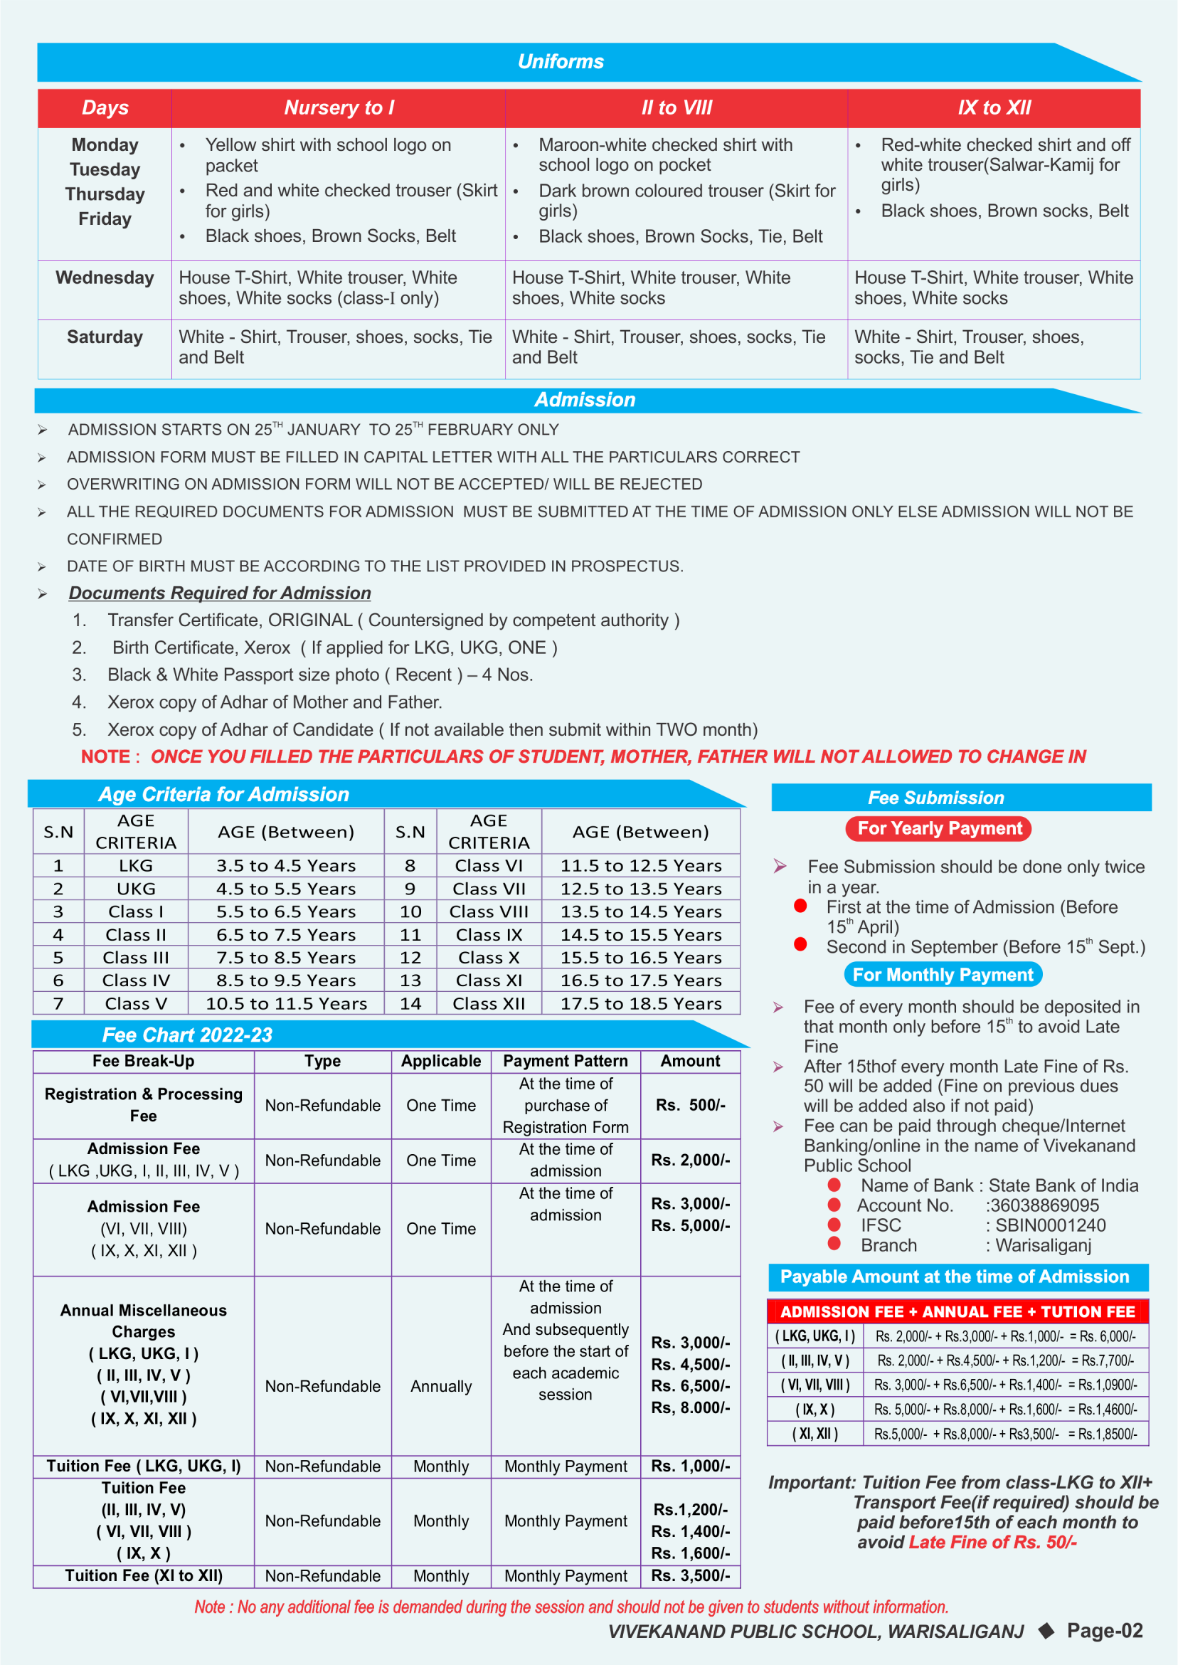

* Apply Online
* Admission Notification
* Rules and Regulations

Tab-3. Academics :

* Students Daily Notice
* Syllabus (Upload as pdf)
* Class-LKG
* Class-UKG
* Class-I
* Class-II

…………. And so on

* Study Materials
* Result

Tab-4. Facilities :

* 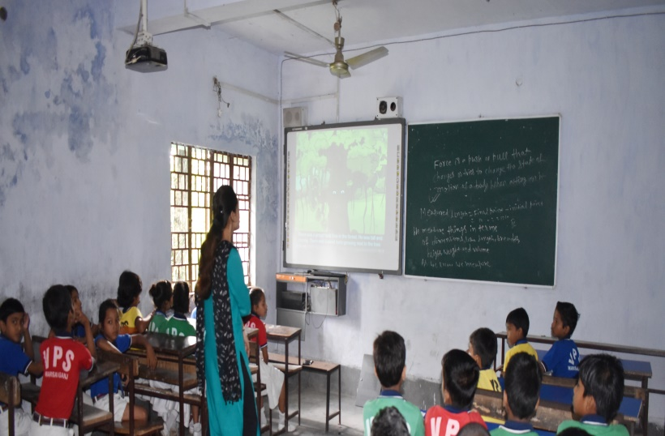Smart class :

One of the recent innovations in computer-aided, hi-tech learning. VPS is one of the few schools in this remote area which have the Smart Class facility. Introduced in 2010, this advanced technology-supported learning system is available to the students of VPS in a regulated manner, under the guidance of supervisors. Ten class rooms have been euipped with this facility the use of which have been arranged regularly and systematically for all the classes.

* Computer Lab :

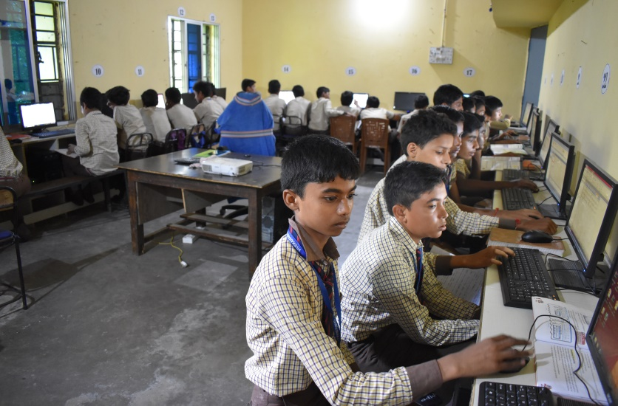

VPS has two Computer Labs: for junior and senior students. Students are advised to make full use of this facility under the guidance of assigned instructors. Regular and systematic learning in computer use has been scheduled for each class through out the academic year. Students are expected to use the computers carefully. Any damage will have to be compensated. Students will have to follow the guidelines of supervisors in the Computer Lab.

* Science Lab:
* 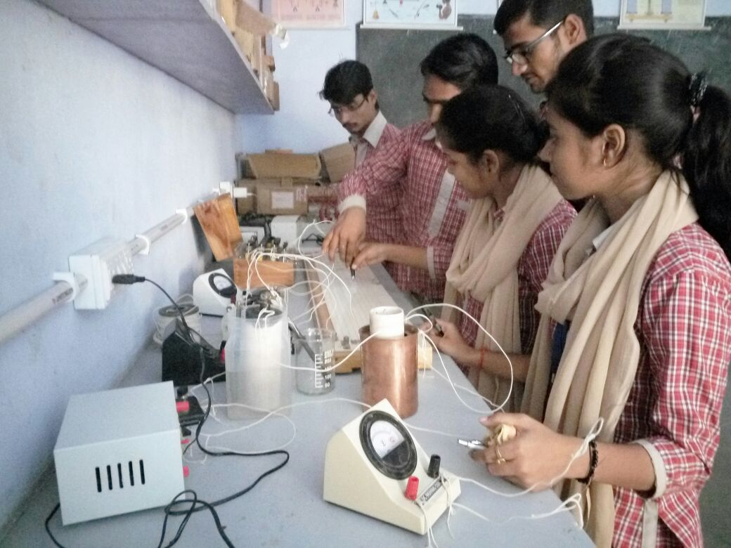Physics Lab:
* 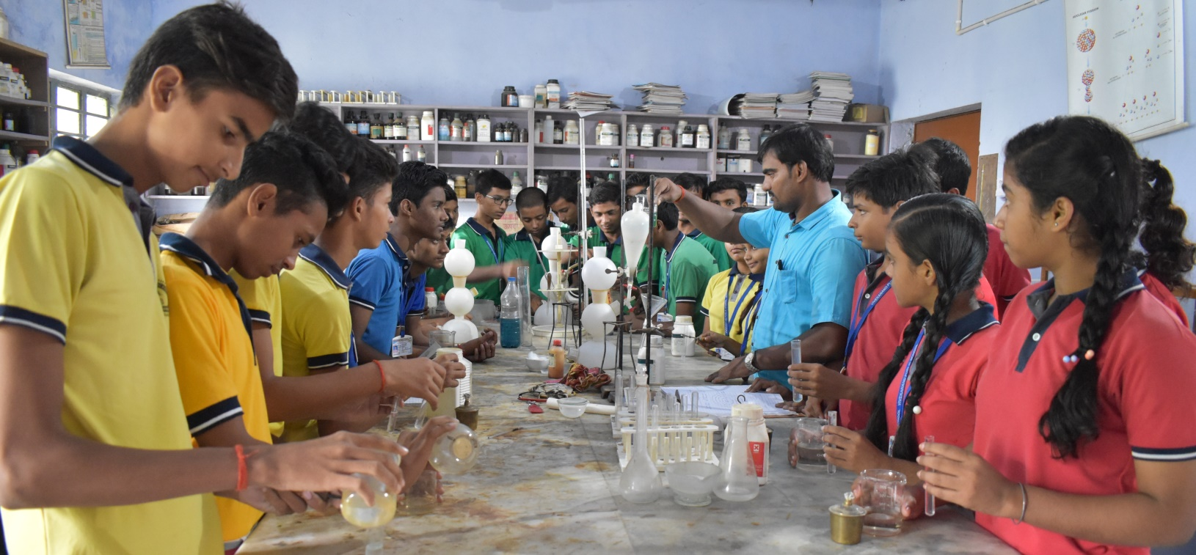Chemistry Lab :
* Biology Lab :

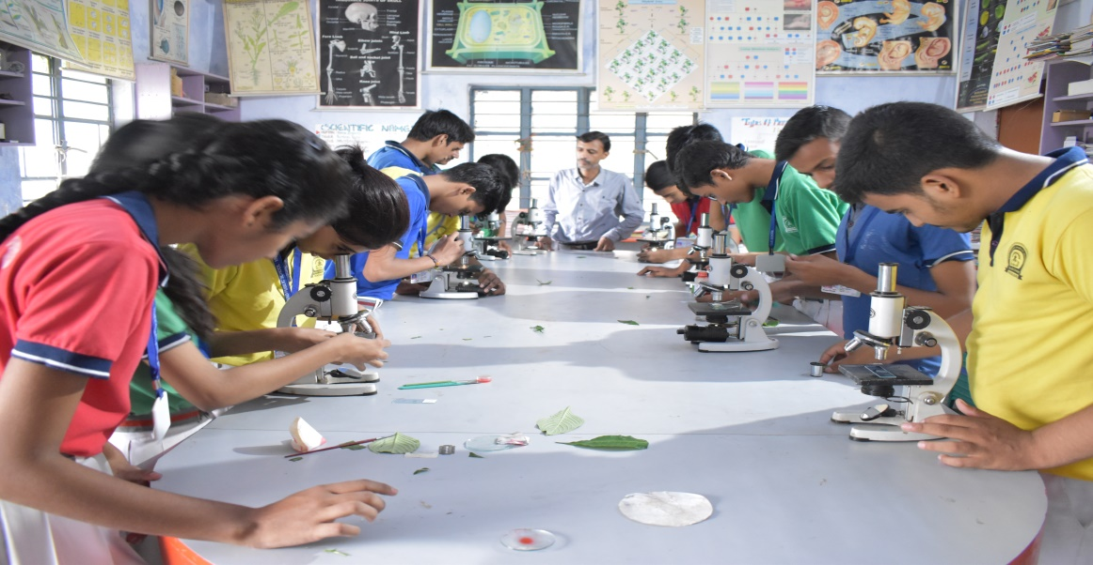

* Maths Lab :

* 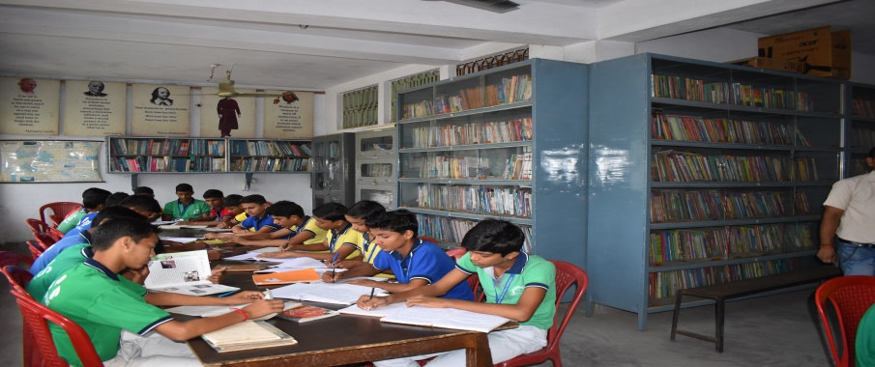Library :

###### The VPS Library is open to all students from Class II onwards. All classes have one Library Period per week. Students visiting the Library have to observe the following rules:

* Every student shall borrow and read books from the Library each month as per the activities listed in the schedule.
* Reference books are not for issue. These books can be read only in the Library.
* If books are returned late without a valid reason, the borrowing facility will be withdrawn for a period of weeks or more.
* Book marked, disfigured, damaged or lost while in their possesion will have to be replaced by the borrower, failing which their parents will be billed thrice the cost of a replacement.
* Any student found deliberately damaging or defacing a book may be debarred from the Library for the entire term or academic year.
* The Library has on open access system, and the students must help maintain the order and oraganization of the collection in different shelves. They must place the books in the shelves strictly according to the call numbers, after consultation with the librarian.
* Student are not allowed to bring their personal books or belongings to the library.
* Library Books should be returned on time, failing which parents willl be asked to report to the School and explain the non-return of the Library books by their ward.
* Strict discipline has to be maintained in the Library.
* It is mandatory for all the students to do the activities slated in the list of activities of Library.
* 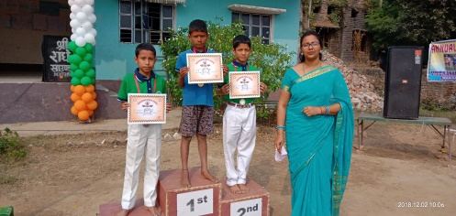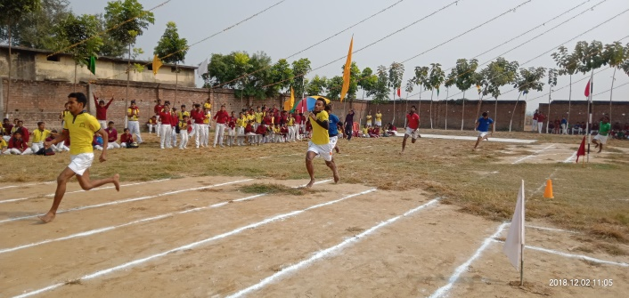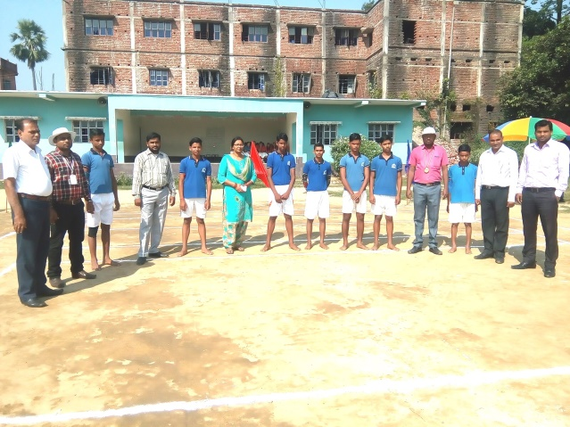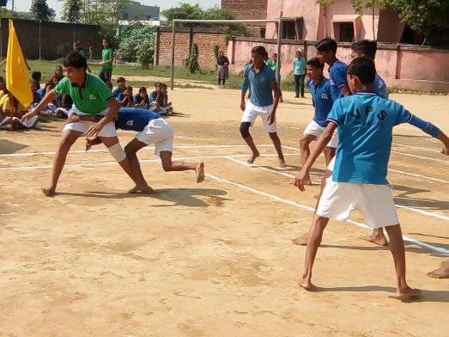Games & Sports :

Tab-5.Gallery :

* Annual Day
* Children Day
* Gandhi Jayanti
* Games & Sports
* Fancy Dress Competition
* Quiz Contest
* Rakhee Making Competition
* Drawing Competition
* Science Exhibition
* Rangoli Competition
* Greeting Card Making Competition
* Birth Anniversary Celebration
* Glass Painting Competition

Tab-6 : Achievements

VPS Achievers

|  |  |  |  |
| --- | --- | --- | --- |
| S.N | Name of Students | Field/Achievement | Year |
| 1 | Nishant Gautam | PGET in BALCO(Bharat Aluminium Company | 2009 |
| 2 | Sonu Kumar | Intelligence Beuro | 2010 |
| 3 | Prashant Kumar | EI(CGL) |  |
| 4 | Balram Pathak | Aeronautical Engineer |  |
| 5 | Mayank Kumar | Engineering(IIT) | 2013 |
| 6 | Chandan Kumar | Engineering(IIT) | 2014 |
| 7 | Deepak Kumar | NIT | 2014 |
| 8 | Sandeep Kumar | Engineering(IIT) | 2015 |
| 9 | Nupur Kumar | Engineering(IIT) | 2015 |
| 10 | Harsh Kumar | Engineering(IIT) | 2015 |
| 11 | Mayank Kumar | Engineering(IIT) | 2015 |
| 12 | Niranjan Pandey | Defence |  |
| 13 | Ramayan Kumar | Banking Sector - |  |
| 14 | Mayank Kumar | IIT | 2016 |
| 15 | Utpal Kant | MBBS | 2017 |
| 16 | Prashant Agrawal | CPT | 2018 |
| 17 | Nisha Agrawal | CPT | 2018 |
| 18 | Sapna Suman | Postal Dept. | 2018 |
| 19. | Vikash Kumar | Postal Dept | 2018 |
| 20 | Ramayan Kumar | Postal Dept. | 2018 |
| 21 | Raj Kamal | Postal Dept. | 2018 |
| 22 | Niranjan Kumar | Bank P.O | 2018 |

Tab-7 : Transfer Certificates

* SELECT CLASS
  + ENTER ADMISSION NO.
  + OK

Tab-8 : Alumni

ALUMNI REGISTRATION FORM

# Student ID

your Admission issued from DPS R.K Puram(e.g R12654,E05463,V05643)

Please give

# Email address

your complete email ID

Please give

# Alumni Name

* Class Section

* Year of Passing

Phone number

Please mention class and section at the time of leaving the school

Status

Select

Select

|  |  |
| --- | --- |
| 1975 | Gender |
|  | |

- -

91

Country code, area code, phone number

Mobile number

91-

# Current Organisation

your current organisation name

Please give

# 

# Current location:

Highest qualification held

Select

Highest qualification held

Select

Specialization/ Major

Institute

Select

If you cannot find your institute listed above, please type it in the box below

Submit